Erosion and Sediment Control Plans
An Erosion and Sediment Control Plan (E&SC Plan) is required for all projects subject to the Construction General Permit and for those projects that are defined as “High” priority projects, as determined by the City’s Construction Site Priority Determination Flowchart. High Priority projects are those projects that may pose a threat to water quality are those projects that disturb 5 acres or less but which have been granted an erosivity waiver by the Water Board, projects required to enroll in the Construction General Permit (GCP) and have NOT received an erosivity waiver OR disturb one or less acres AND have one or more of the following water quality concerns:
- Project disturbance of 50 cu yds to 1 acre of soil;
- potential to discharge directly or indirectly into a Creek;
- direct contact with groundwater;
- are tributary to a 303(d) waterbody and generates the pollutant the waterbody is impaired for (http://www.waterboards.ca.gov/water_issues/programs/tmdl/integrated2010.shtml);
- have cuts/fills in excess of four feet;
- have slopes exceeding 20% for distances greater than 50-feet
- are to be implemented by a contractor with a history of non-compliance.
PURPOSE
This checklist has been developed to assist applicants in obtaining City approval. The goal of the E&SC Plan is to:
- Minimize the amount of disturbed soil;
- Eliminate non-storm runoff;
- Eliminate sediment and/or other pollutants from exiting the construction site; and
- Ensure construction materials are managed properly.
Erosion control is any source control measure that protects the soil surface and prevents soil particles from being detached by rainfall, flowing water or wind. Erosion control is also referred to as soil stabilization. Erosion control consists of preparing the soil surface and implementing one or more erosion control measures to disturbed soil areas.
Sediment control is any practice that traps soil particles after they have been detached and moved by rain, flowing water or wind. Sediment control measures are usually passive systems that rely on filtering or settling the particles out of the water or wind that is transporting them. Sediment control measures include those practices that intercept and slow or detain the flow of storm water to allow sediment to settle and be trapped.
A Storm Water Pollution Prevention Plan (SWPPP) shall be provided for all projects subject to the Construction General Permit (CGP). The SWPPP shall be prepared by a Qualified SWPPP Developer (QSD) and be in compliance with all aspects of the CGP. No earth disturbing work shall begin until the City has been provided with record of the Waste Discharge Identification Number (WDID) issued for the project.
All applicable environmental permits (RWQCB 401 Certification, CA Fish & Wildlife 1601, ACOE nationwide permit, etc.) shall be included as an appendix in the SWPPP or WPCP.
This checklist provides the minimum standards for an erosion and sediment control plan. Your selection of the best soil erosion and sediment controls for your site should be primarily based upon the nature of the construction activity and the conditions which exist at the construction site. Additional resources are available at:
  - https://www.casqa.org/resources/bmp-handbooks
  - http://www.dot.ca.gov/hq/construc/stormwater/manuals.htm
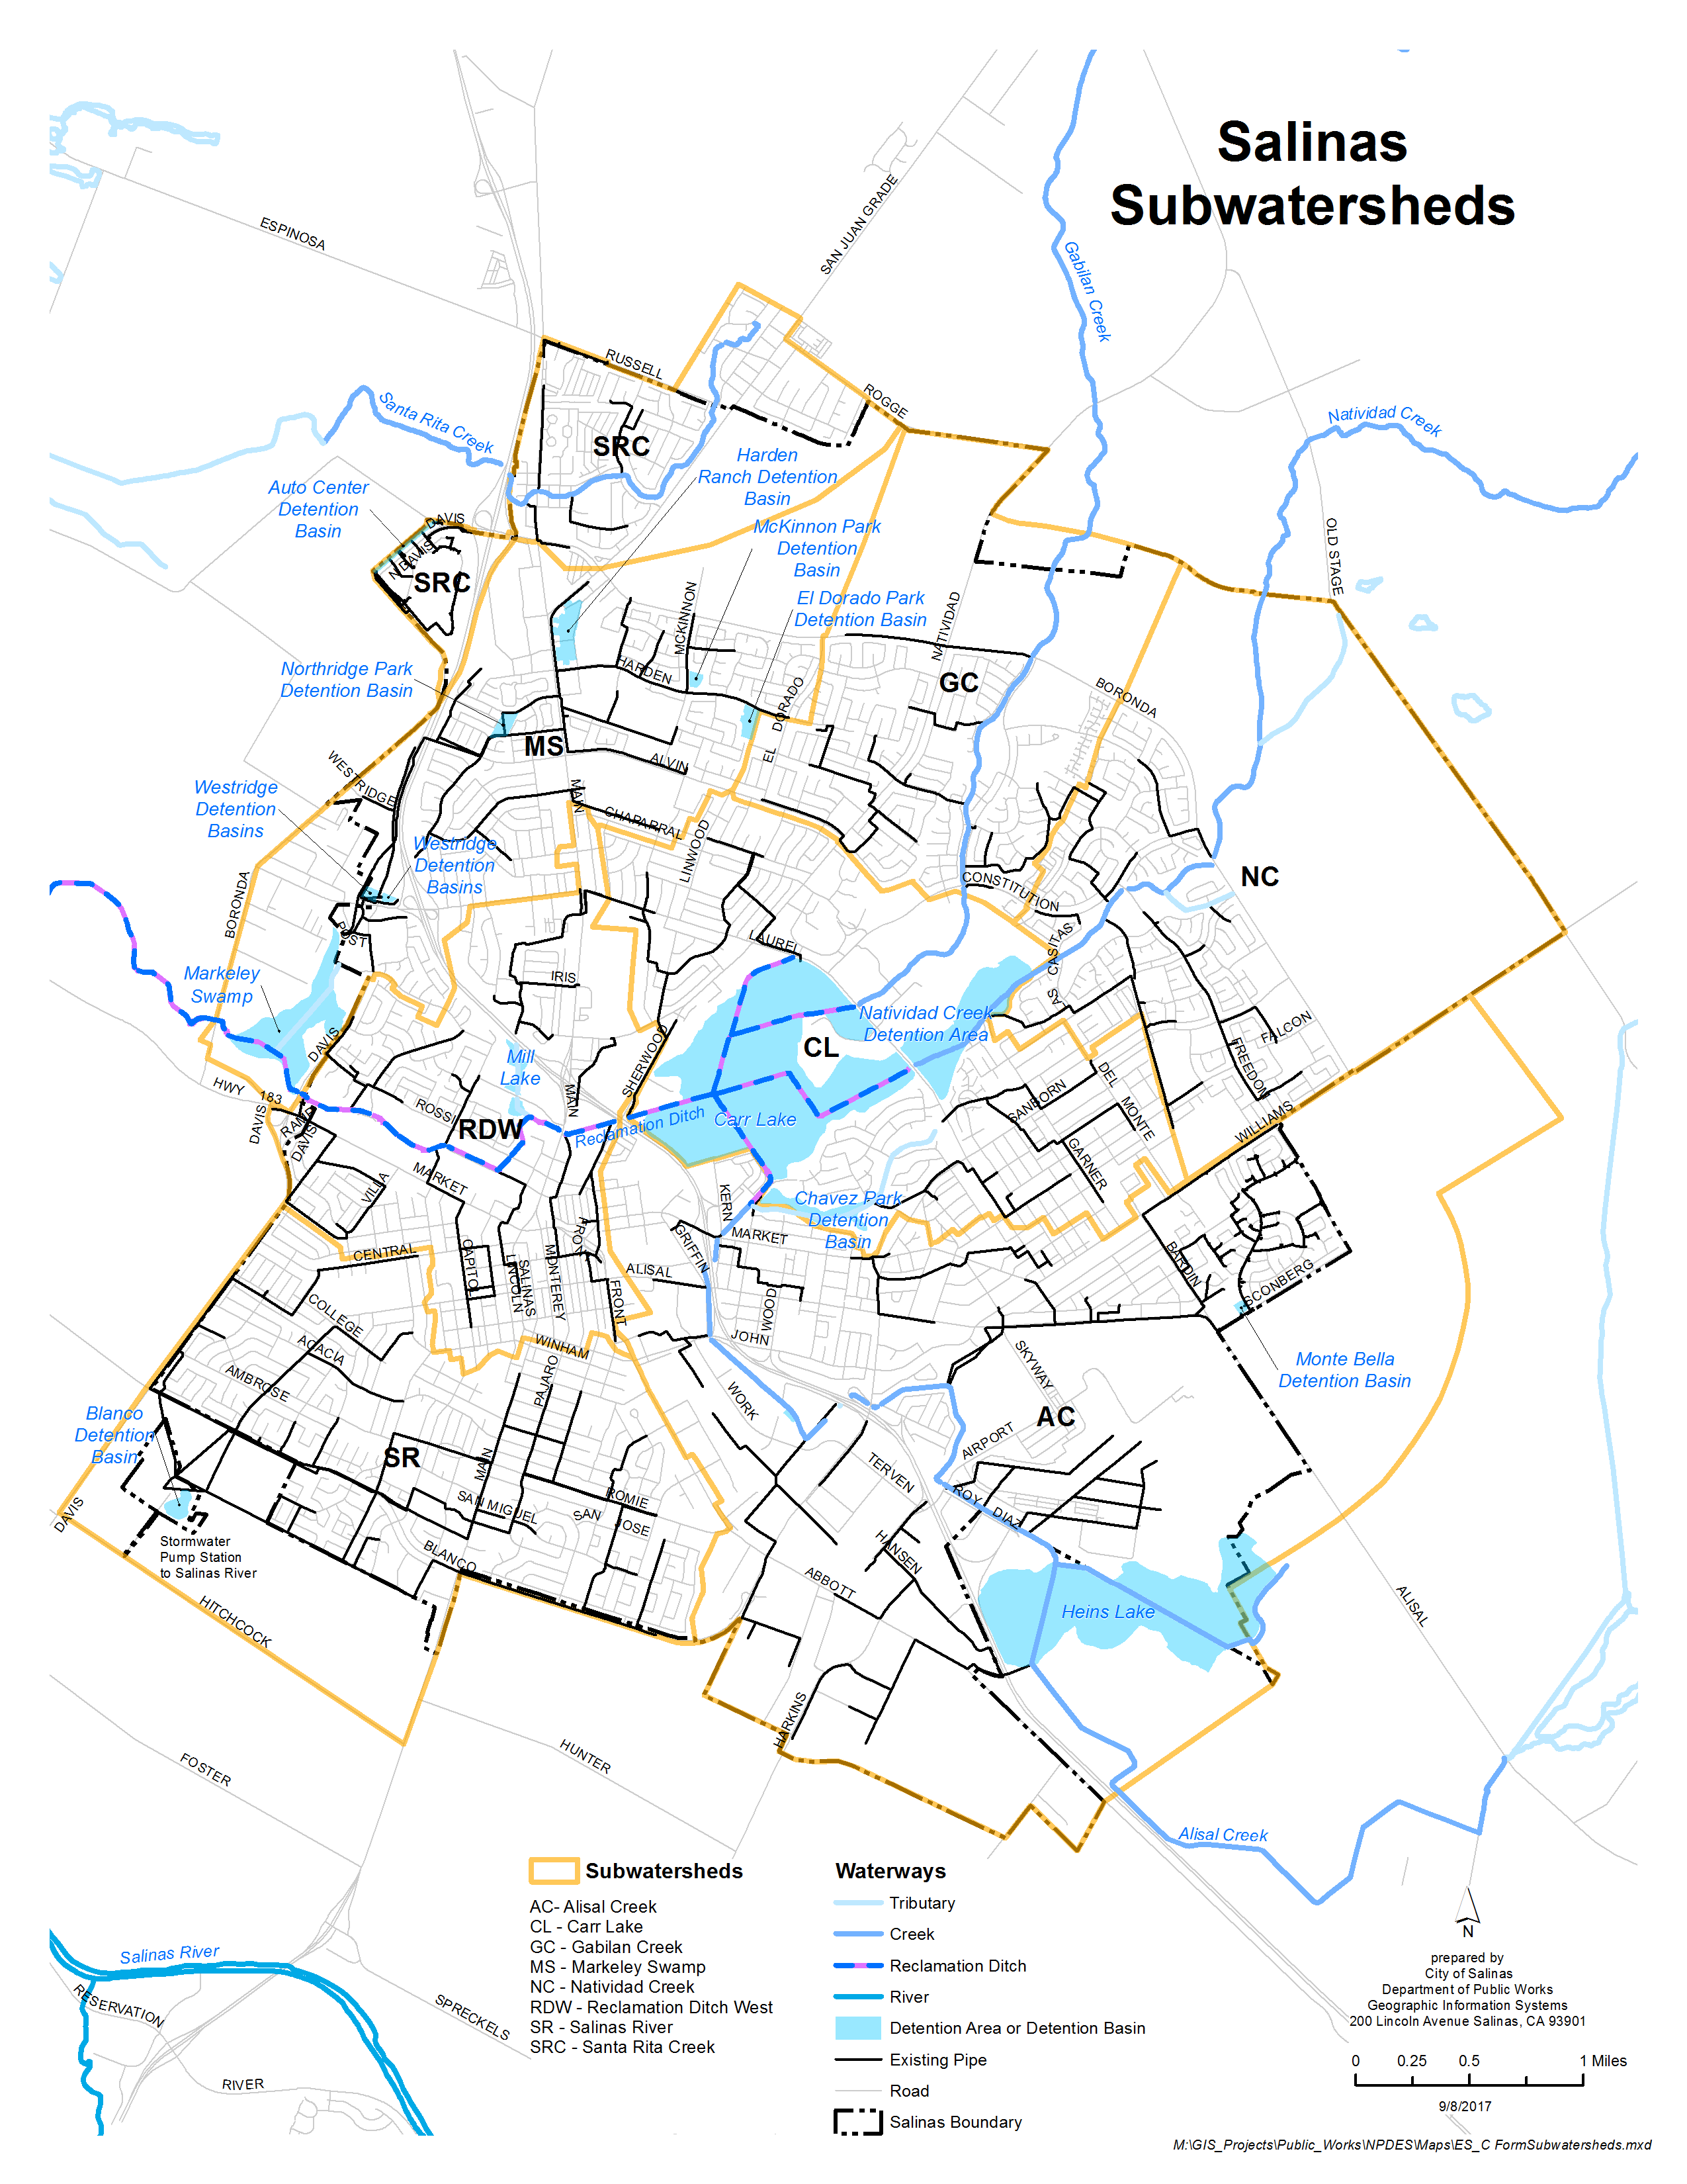
CONSTRUCTION SITE PRIORITY DETERMINATION
In accordance with the City of Salinas Municipal Permit, each construction site with storm water BMP requirements must have a designated priority: High or Low. The flow chart below provides as guidance to determine the priority of a construction site. The Construction Prioritization must be completed using this form, noted on the plans and included in the SWPPP and/or Erosion Control Plan.
*HIGH
PRIORITY
REQUIRES
A SWPPP
1 acre or more of disturbed soil?
☐ Yes

☐ No
Is site tributary to a CWA 303(d) water body impaired by sediment OR within 100 feet of or discharging to a riparian area?
50 cy to 1 acre of disturbed soil?
☐ Yes ☐ Yes
*HIGH
PRIORITY

☐ No
☐ No
Does the site have a high erosion potential and/or significant slope?
Is site tributary to a CWA 303(d) water body impaired by sediment OR within 100 feet of or discharging to a riparian area?
☐ Yes ☐ Yes
*HIGH
PRIORITY

☐ No ☐ No
*LOW
PRIORITY
*LOW
PRIORITY

*Sites with a low threat to water quality priority can be given a higher threat prioritization at the discretion of City staff based on additional factors, such as project type, contact with groundwater, non-storm water discharge potential and past non-compliance by the operators of a construction site.

Note: High soil erosion potential and significant slope are those with cut/fills in excess of four (4) feet; or have slopes exceeding 20% for distances greater than 50 feet.

Per the above flow chart, this project has the following threat to water quality:
☐ High Priority ☐ Low Priority
Note: Construction Priority DOES NOT alter construction BMP requirements that apply to all projects; all construction BMP requirements must be identified on a case-by-case basis. Construction Priority DOES affect the frequency of inspections that will be conducted by the City.

Completed By: Click or tap here to enter text. Phone: Click or tap here to enter text.
Project Address: Click or tap here to enter text. Permit No.: Click or tap here to enter text.
Priority : Choose an item. Risk Assessment:Not Applicable
Erosion & Sediment Control Plan Checklist for High Priority Projects
 | Required |  |  | Provided |  | N/A
GENERAL
1. | ☐ |  |  | ☐ |  | ☐ |  | Name and 24-hour contact information for the contractor/person responsible for implementing and maintaining the BMPs, the QSD, QSP and LRP contact information.
2. | ☐ |  |  | ☐ |  | ☐ |  | WDID Number and dates used for risk assessment calculations, if project subject to the Construction General Permit.
3. | ☐ |  |  | ☐ |  | ☐ |  | Vicinity Map, identify receiving water body (Creek, Basin, City Storm Drain System), nearby roadways, and general topography surrounding the site.
4. | ☐ |  |  | ☐ |  | ☐ |  | Detail limits of construction site boundaries, show locations of run-on and run-off from site.
5. | ☐ |  |  | ☐ |  | ☐ |  | Drainage areas and flow lines
6. | ☐ |  |  | ☐ |  | ☐ |  | Identify discharge and sampling locations
7. | ☐ |  |  | ☐ |  | ☐ |  | Delineate areas of temporary and permanent soil disturbance
8. | ☐ |  |  | ☐ |  | ☐ |  | Delineate active areas of cut or fill; areas where soil disturbance activities will occur
9. | ☐ |  |  | ☐ |  | ☐ |  | Delineate and note protection for all sensitive habits, watercourse or other features that are not to be disturbed.
10. | ☐ |  |  | ☐ |  | ☐ |  | Locations (and types) of all post-construction BMPs.
11. | ☐ |  |  | ☐ |  | ☐ |  | Topography and planned site elements (e.g., buildings, landscaped areas) before and after construction.
12. | ☐ |  |  | ☐ |  | ☐ |  | During the Rainy Season (October 1 to April 30):  - Grading activities must be scheduled to minimize bare graded areas.  - Sufficient quantities of erosion control materials shall be kept on site at all times to be installed as soon as possible and prior to likely precipitation events.
13. | ☐ |  |  | ☐ |  | ☐ |  | Natural features, including vegetation, terrain, watercourse and similar resources shall be preserved, where possible.
14. | ☐ |  |  | ☐ |  | ☐ |  | Minimize soil compaction for areas that will remain pervious or used for stormwater control measures (SCMs).
15. | ☐ |  |  | ☐ |  | ☐ |  | Where feasible, top soil shall be stockpiled and reapplied upon completion of grading on slopes of less than twenty percent.
16. | ☐ |  |  | ☐ |  | ☐ |  | Provide a detailed, site-specific listing of potential sources of stormwater pollution (note if included in SWPPP).
17. | ☐ |  |  | ☐ |  | ☐ |  | Provide the rationale used for selecting BMPs, including how the BMP protects a waterway or stormwater conveyance system. (Shall be included in SWPPP or SWCP).
18. | ☐ |  |  | ☐ |  | ☐ |  | Provide details on Erosion and Sediment Control Plan
EROSION AND SEDIMENT CONTROL
19. | ☐ |  |  | ☐ |  | ☐ |  | Show locations and details of erosion and sediment control BMPs (type, why being used, how protects the waterways, etc).
20. | ☐ |  |  | ☐ |  | ☐ |  | Show planned perimeter controls and methods to delineate limits of grading.
 | Required |  |  | Provided |  | N/A
21. | ☐ |  |  | ☐ |  | ☐ |  | If sediment basins will be used, provide evidence that basin was designed in accordance with CASQA’s BMP Guidance Book.
22. | ☐ |  |  | ☐ |  | ☐ |  | Effective soil cover shall be provided on all finished slopes, open space, utility backfill and completed lots that are not scheduled to be re-disturbed for minimally 14 days.
23. | ☐ |  |  | ☐ |  | ☐ |  | Show all storm drain inlets where runoff from site could enter the storm drain system and detail how the inlets shall be protected from silt and debris from the site.
TRACKING CONTROL / STABILIZED CONSTRUCTION ENTRANCE / EXIT
24. |  | ☐ | ☐ |  | ☐ |  | Show and detail stabilized entrance for trucks and other equipment to enter and leave property without tracking onto the public or private street
25. |  | ☐ | ☐ |  | ☐ |  | Access roads shall be cleaned (swept) daily (if necessary) and prior to any rain event.
WIND EROSION CONTROL
25. |  | ☐ | ☐ |  | ☐ |  | Indicate on the plan the dust control practices to be used.
MATERIALS AND WASTE MANAGEMENT
26. |  | ☐ | ☐ |  | ☐ |  | Show location of waste material dumpster, require dumpster be covered nightly and protected from rain, has secondary containment.
27. |  | ☐ | ☐ |  | ☐ |  | Provide locations of storage areas for waste, vehicles, service, loading/unloading of materials, fueling, and water storage.
28. |  | ☐ | ☐ |  | ☐ |  | Provide locations for soil stockpiles areas (if applicable) and show how they will be protected against erosion.
29. |  | ☐ | ☐ |  | ☐ |  | Require that construction materials that are not actively being used be covered and bermed.
30. |  | ☐ | ☐ |  | ☐ |  | Show locations of porta-potties with secondary containment.
31. |  | ☐ | ☐ |  | ☐ |  | Show location of and detail washout area/waste pit for disposal of “wet” construction materials such as concrete, stucco and paint.
CONSTRUCTION INSPECTION REQUIREMENTS (ADD AS NOTES ON PLANS)
32. |  | ☐ | ☐ |  | ☐ |  | Prior to commencement of any land disturbance, the contractor shall schedule an inspection with the City of Salinas to ensure all necessary sediment controls are in place and in compliance with Caltrans or CASQA BMP Fact Sheets.
33. |  | ☐ | ☐ |  | ☐ |  | During construction, inspections by the City of Salinas will be conducted to inspect drainage device installation, review the maintenance and effectiveness of BMPs installed, as well as, to verify that pollutants of concern are not discharged from the site.
34. |  | ☐ | ☐ |  | ☐ |  | Prior to final inspection, the contractor shall schedule an inspection with the City of Salinas to ensure that all disturbed areas have been stabilized and that all temporary erosion and sediment control measures that are no longer needed have been removed.
35. |  | ☐ | ☐ |  | ☐ |  | Contractor shall schedule inspections with the City of Salinas at all stages of source control measures construction.

Project Address: Click or tap here to enter text. Permit No.: Click or tap here to enter text.
Erosion & Sediment Control Plan Checklist for Low Priority Projects
 | Required | Provided | N/A
GENERAL
1. | ☐ | ☐ | ☐ | Provide name and contact information for the contractor/person responsible for implementing and maintaining the BMPs.
2. | ☐ | ☐ | ☐ | Show vicinity map, identify any nearby receiving water body (Creek, Basin, City Storm Drain System) and nearby roadways.
3. | ☐ | ☐ | ☐ | Delineate limits of construction site boundaries and areas of soil disturbance.
4. | ☐ | ☐ | ☐ | Delineate drainage areas and flow patterns, including run-on and run-off.
5. | ☐ | ☐ | ☐ | Identify and delineate all sensitive habits, watercourse, or other features that are not to be disturbed.
6. | ☐ | ☐ | ☐ | Show locations (and types) of all post-construction (LID) features.
7. | ☐ | ☐ | ☐ | Show topography and site features (e.g., buildings, paved and landscaped areas) before and after construction.
EROSION AND SEDIMENT CONTROL
8. | ☐ | ☐ | ☐ | Show locations and details of erosion and sediment control BMPs, including down slope controls and slope protection.
9. | ☐ | ☐ | ☐ | Show all storm drain inlets where runoff from site could enter the storm drain system and detail how the inlets shall be protected from silt and debris from the site.
10. | ☐ | ☐ | ☐ | Show stockpile locations, if applicable, and show how they will be protected against erosion.
11. | ☐ | ☐ | ☐ | Add note: Natural features, including vegetation, terrain, watercourse and similar resources shall be preserved, where possible.
12. | ☐ | ☐ | ☐ | Add note:  During the Rainy Season (October 1 to April 30):  - Grading activities must be scheduled to minimize bare graded areas.  - Sufficient quantities of erosion control materials shall be kept on site at all times to be installed as soon as possible and prior to likely precipitation events.
13. | ☐ | ☐ | ☐ | Add note: Effective soil cover shall be provided on all finished slopes, open space, utility backfill and completed lots that are not scheduled to be re-disturbed for minimally 14 days.
14. | ☐ | ☐ | ☐ | Add note: Minimize soil compaction for areas that will remain pervious or used for LID measures.
15. | ☐ | ☐ | ☐ | Add note: Where feasible, top soil shall be stockpiled and reapplied upon completion of grading on slopes of less than twenty percent.
TRACKING CONTROL / STABILIZED CONSTRUCTION ENTRANCE / EXIT
16. | ☐ | ☐ | ☐ | Show and detail stabilized entrance for trucks and other equipment to enter and leave property without tracking onto the public or private street
17. | ☐ | ☐ | ☐ | Add note: Access roads shall be cleaned/swept daily as required and prior to any rain event.

 | Required | Provided | N/A
WIND EROSION CONTROL
18. | ☐ | ☐ | ☐ | Indicate on the plan the dust control practices to be used.
MATERIALS AND WASTE MANAGEMENT
19. | ☐ | ☐ | ☐ | Add note: Waste material dumpster shall be covered nightly and protected from rain.
20. | ☐ | ☐ | ☐ | Add note: All construction materials that are not actively being used must be raised and covered.
21. | ☐ | ☐ | ☐ | Show locations of porta-potties with secondary containment, indicate on plan if no porta-potties will be used.
22. | ☐ | ☐ | ☐ | Show location of and detail washout area/waste pit for disposal of “wet” construction materials such as concrete, stucco and paint.
CONSTRUCTION INSPECTION REQUIREMENTS (ADD AS NOTES ON PLANS)
23. | ☐ | ☐ | ☐ | Prior to commencement of any land disturbance, the contractor shall schedule an inspection with the City of Salinas to ensure all necessary sediment controls are in place and in compliance with Caltrans or CASQA BMP Fact Sheets.
24. | ☐ | ☐ | ☐ | During construction, inspections by the City of Salinas will be conducted to inspect drainage device installation, review the maintenance and effectiveness of BMPs installed, as well as, to verify that pollutants of concern are not discharged from the site.
25. | ☐ | ☐ | ☐ | Prior to final inspection, the contractor shall schedule an inspection with the City of Salinas to ensure that all disturbed areas have been stabilized and that all temporary erosion and sediment control measures that are no longer needed have been removed.
26. | ☐ | ☐ | ☐ | Contractor shall schedule inspections with the City of Salinas at all stages of construction of the post construction (LID) features.
REVIEW SUMMARY

☐ E&SC Plan requires revisions. See comments below or on following pages.

☐ E&SC Plan approved. Date Approved: Click or tap to enter a date.
REVIEW COMMENTS AND REQUIRED CORRECTIONS:
Click or tap here to enter text.

